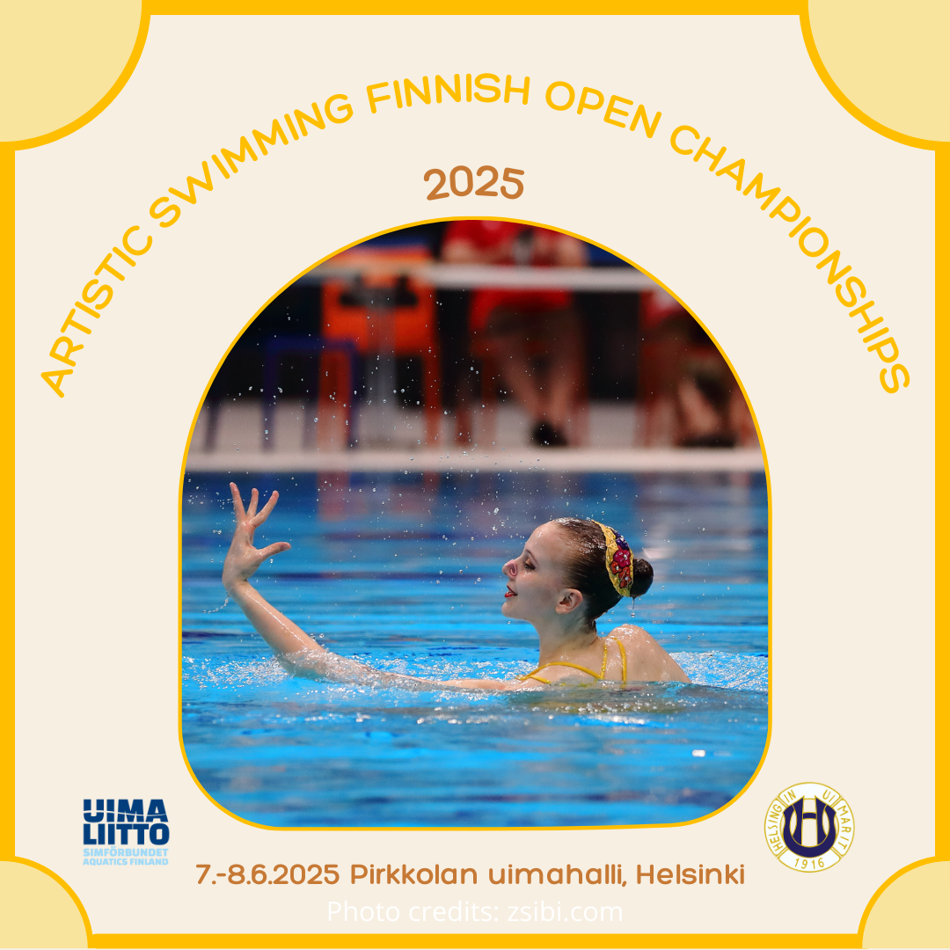

Finnish Swimming Federation and Swimming Club Helsingin Uimarit Ry have a pleasure to invite all artistic swimmers to Finnish open Junior and Senior championships in ~~juniors and seniors~~ on 7.-8.6.2025 at Pirkkola swimming hall!

Organizing club: Helsingin Uimarit Ry

Time: 7.-8.6.2025

Place: Pirkkola sports park swimming hall (Pirkkolan metsätie 6, Helsinki)

Referee: Venla Manninen

Chief Recorder: Anniina Vattulainen Erkkilä

Difficulty controller (DTC): Anna Kaján

Competition doctor: Emilia Toikkanen

Head volunteer: Vuokko Haaparanta

Harassment contact: Peppi Hietanen / peppi.hietanen@helsinginuimarit.fi

Competiton coordinator: Heidi Tuominen

Competition page: [Artistic Swimming Finnish Open Championships 2025 - Helsingin Uimarit](https://www.helsinginuimarit.fi/taitouinti/kilpailut/artistic-swimming-finnish-open-cham-2/)

Competition pool: Indoor pool. Pool profile 1,5m-4m. 25 x 16 m.

There will be a starting deck at the venue – appr. 2m x 5 meters, height appr. 70cm.

Rules: The competition follows Finnish Swimming Federations’s rules and regulations as well as the current World Aquatics artistic swimming rules and World Aquatics General Rules.

Participation: In Finnish Championships rules 3.2.1 all competitors can swim in their own age category and in older.

License: Every Finnish participant must have a valid Blue Card license. For other participants it is not required.

Registration: Preliminary entries must be sent latest on Tuesday 13th of May.

Final entries must be sent lastest on Tuesday 20th of May.

Please use the entry form available on the competition website and send them via email ([heidi.tuominen@helsinginuimarit.fi](mailto:heidi.tuominen@helsinginuimarit.fi)).

Entry fees: Entry fees for the competition are:

* Solos (technical and free) 25 € / routine
* Duets (technical and free) 35 € / routine
* Mixed duets (technical and free) 35 € / routine
* Team (technical and free) 80 € / routine
* Acrobatic routine 80 € / routine
* Free combination 100 € / routine

**Payments must be made latest on 20th of May:**

Receiver: Helsingin Uimarit Ry

Bank ID: Nordea FI68 1256 3000 0439 38

Message: ARTISTIC SWIMMING FINNISH OPEN CHAMPIONSHIPS 2025 / ENTRY FEES / CLUB’S NAME or FEDERATION

All payments will be checked before the competition and without payments swimmers can’t start. The payments are tripled if the final entry is sent later than the informed date

Events: The competition is held in the following events:

|  |  |
| --- | --- |
| Junior | * Solo technical 100 % * Solo free 100 % * Male solo technical 100 % * Male solo free 100 % * Duet technical 100 % * Duet free 100 % * Mixed duet technical 100 % * Mixed mixed duet free 100 % * Team technical 100 % * Team free 100 % * Free combination 100 % * Acrobatic routine 100 % |
| Senior | * Solo technical 100 % * Solo free 100 % * Male solo technical 100 % * Male solo free 100 % * Duet technical 100 % * Duet free 100 % * Mixed duet technical 100 % * Mixed mixed duet free 100 % * Team technical 100 % * Team free 100 % * Free combination 100 % * Acrobatic routine 100 % |

According to Finnish championship’s rules every competitor must start all routines in each category they have been entered to. For example if a solo is entered to both junior and senior category it must be started in both categories as well.

Materials: **Coach cards must be uploaded to the club’s folder latest on Wednesday 28th of May.** A link to the folder will be sent to the clubs after the final entries. Please use the coach card template available at the competition page and name the files as:

Nationality_Club_agegroup_event_Team/Surname

**Music files must be uploaded to the club’s folder latest on Wednesday 28th of May.** A link to the folder will be sent to the clubs after the final entries. Please name the files as:

Nationality_Club_agegroup_event_Team/Surname

Officials: Every Finnish club should suggest names for judges, STC and DTC in the entry form. Foreign countries/clubs must bring officials at their own expense.

Warm up: There is a warm up scheduled for each session in the competition pool. The warm up times are reserved only for the swimmers taking part in the current session. The education pool next to the competition pool is also available for warm up during the whole competition. We however ask to keep quiet when warming up during the competition.

There is no music warm up. All musics will be tested shortly before each start.

Schedule: Preliminary schedule of the competition:

Saturday 7.6.

9.00-9.30 judges’ and team leaders’ meeting

9.00-21.00 warm up and competition

Sunday 8.6.

9.00-9.30 judges’ and team leaders’ meeting

9.00-16.00 warm up and competition

Start lists: Start lists will be drawn 4th of June at 17.00 at Helsingin Uimarit ry’s office (Laurinniityntie 2 C, Helsinki). There will also be a Teams link provided to watch the draw online as well.

Awards: There will be two separate competitions held in the competition: Finnish championships and open competition in which competitors from other countries can take part in.

In both competitions places from 1st to 3rd will be awarded with medals and places from 1st to 6th with digital diplomas.

Transportation: Pirkkola Sports Park features two parking areas on different sides of the park. The so-called ice hall parking area is located along Pirkkolantie, at Plotinrinne 1, to be exact. This parking is free of charge.

The so-called swimming hall parking area is located at Pirkkolan metsätie 6. The swimming hall parking area also has disabled parking. The parking must be payed for and the information is provided at the parking lot.

When arriving with public transportation there are buses that stop at Hämeenlinnanväylä or Pirkkolantie or with light rail line 15. There is also a city bike station at the swimming hall parking lot.

Meals: Clubs can book meals for the competition weekend at Jani’s Sport Bar & Cafe, which is located in the swimming hall lobby. All meals must be reserved in advance by 25th of May through the link provided. Meals must be payed in advance and there will be an invoice sent to the club’s who have reserved them. See attachment 2 for further information regarding the meals.

Reservations for the competition meals: [Meal orders / ruokailutilaukset - Helsingin Uimarit](https://www.helsinginuimarit.fi/taitouinti/kilpailut/artistic-swimming-finnish-open-cham-2/meal-orders-ruokailutilaukset/)

Accomodation: All participants must book their own accomodation for the competition.

Hotel Central Haaga offers a discount on stays for the participants of the competition in 20 minutes walking distance from the venue. A double room with double bed is available for 185,73€/night.

The hotel is pretty busy on the competition weekend but there is a small number of rooms reserved for the competition participants. Bookings to Hotel Central Haaga can be made through the reception by calling (+358 9 5807877) or via email (hotel@haaga.fi). For the discounted price please mention the code ”Taitouinnin SM-kilpailut/Artistic Swimming Finnish Championships” when booking your stay.

Other accomodation options close by are Sokos Hotel Tripla and Scandic Pasila.

There is a big football game on the competition weekend in Helsinki which might show in the hotel reservations.

Spectators: Spectators must purchase a ticket to the competition. There are multiple ticket options available:

* One competition session (either morning or evening) 5 euros
* One competition day 8 euros
* Whole competition weekend 13 euros

Spectators can purchase tickets at the competition venue. Only card payments are accepted.

All participating clubs or federations must include coaches and/or team leader’s in the final entry. All coaches, team leaders and swimmers will receive accreditation passes when arriving to the competition venue. You may enter a maximum of two coaches or team leaders (all together) per each starting 12 athletes per club.

Competition activities: There will be snacks, beverages, coffee and tea available for the officials and coaches during the competition at the meeting room in the swimming hall lobby.

There will be a raffle organized on the competition venue. Further information will be updated to the competition page.

Attachments: Entry form (attachment 1)

Advert for competition meals (attachment 2)

Coach card -template (attachment 3)

Contact person: Heidi Tuominen / [heidi.tuominen@helsinginuimarit.fi](mailto:heidi.tuominen@helsinginuimarit.fi)

Cover photo credits: zsibi.com

Welcome to Pirkkola!