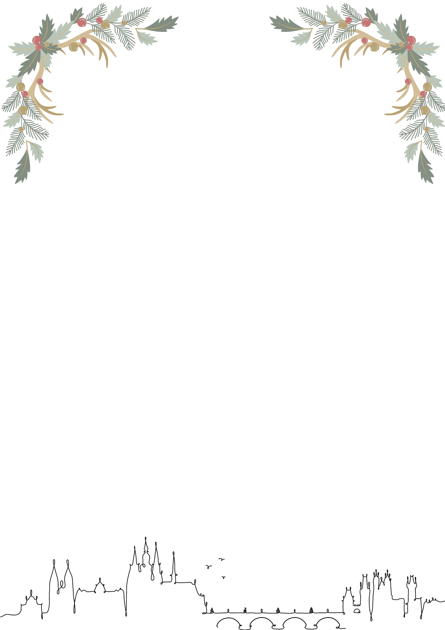

Preliminary entry form – Christmas Prize Prague 2023

Club (Club abbreviation): _____________________________________________________________
Contact: ___________________________________________________________________________

- YOUTH:
  - Figures: 0
  - Duet: 0
  - Mix duet: 0
  - Team: 0
  - Free combination: 0

- SENIORS:
- Free routines:
  - Solo female (max 2): 0
  - Duet: 0
  - Mix duet: 0
  - Team: 0
  - Acrobatic routine: 0
- Technical routines:
  - Duet: 0
  - Mix duet: 0
  - Team: 0

- OTHERS:
- Judges: 1
- Technical Controller: 0
- Preliminary number of lunches (Non-binding): 0

Date:
Signature:

